** Name:** Tusarjyoti Das

**Question 1**

Write a python program that takes two numbers as the input and print the result of Addition,

Subtraction, Multiplication, Division of the two numbers:

Ans:

**Code:**

n1=int(input("Enter the 1st Value: "))

n2=int(input("Enter the 2nd Value: "))

print('Addition',n1+n2)

print('Subtraction',n1-n2)

print('Multiplication',n1*n2)

print('Division ',n1/n2)

**Output:**

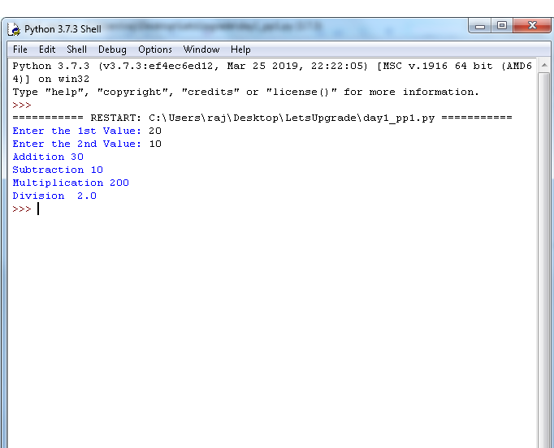

**Question 2**

Write a python program that takes two numbers as the input such as X and Y and print the result

of X^Y(X to the power of Y):

Ans:

**Code:**

x=int(input("Emter the Base Value: "))

y=int(input("Emter the power Value: "))

a=x**y

print(x,"to the power of",y,"=", a)

**Output:**

